Project Design Phase-II
Data Flow Diagram & User Stories

Date | 11 October 2026
Team ID | ServiceNow - A2
Project Name | Car Rental Request Automation in ServiceNow
Maximum Marks | 4 Marks

Data Flow Diagrams:
A Data Flow Diagram (DFD) is a traditional visual representation of the information flows within a system. A neat and clear DFD can depict the right amount of the system requirement graphically. It shows how data enters and leaves the system, what changes the information, and where data is stored.
Example: DFD Level 0 (Industry Standard)

Example: (Simplified)
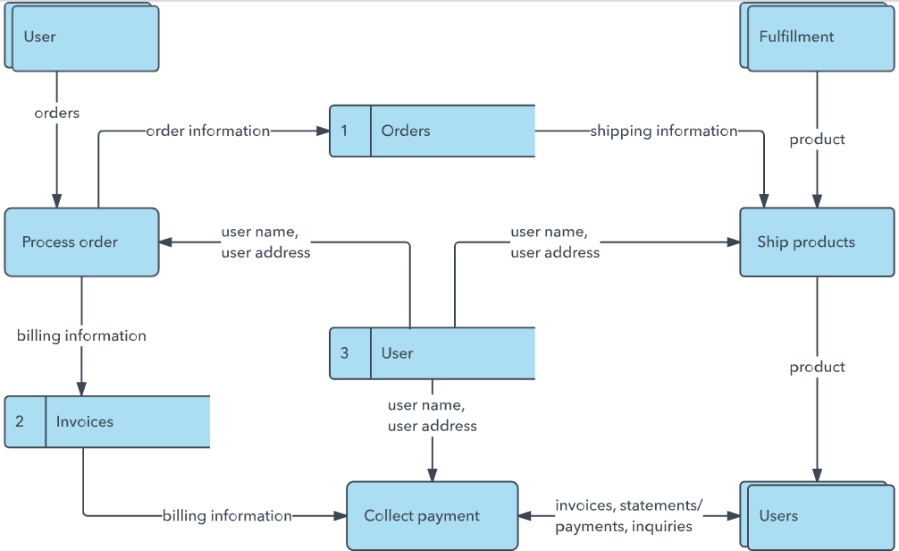

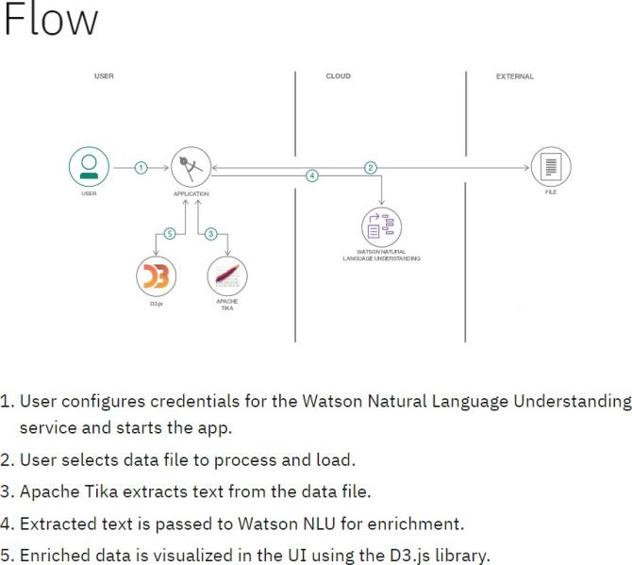

User Stories
Use the below template to list all the user stories for the product.

User Type | Functional Requirement (Epic) | User Story Number | User Story / Task | Acceptance criteria | Priority | Release
Employee / Requester | Car Rental Request | USN-1 | As an employee, I can open the Car Rental Request catalog  item so that I can request a vehicle for official travel. | Catalog item is accessible and  displays all required request fields. | High | Sprint-1
Employee / Requester | Car Rental Request | USN-2 | As an employee, I can enter pickup/drop-off locations, travel dates and times, car type and travel purpose. | Required fields are available and mandatory fields prevent  incomplete submission. | High | Sprint-1
Employee / Requester | Car Rental Request | USN-3 | As an employee, I can submit the request and receive a  request/RITM reference number. | Request is created successfully and  RITM number is generated. | High | Sprint-1
Approver | Approval | USN-4 | As an approver, I can review the car rental request and  approve or reject it. | Approval decision is recorded  against the request. | High | Sprint-1
Transport Team | Assignment | USN-5 | As a Transport team member, I receive approved car rental requests assigned to my group. | Approved request is automatically routed to the Transport assignment  group. | High | Sprint-1
Transport Team | Availability | USN-6 | As a Transport team member, I can review the requested  dates, locations and car type and confirm availability. | Availability/fulfillment information  is recorded on the RITM. | High | Sprint-2
Employee / Requester | Tracking | USN-7 | As an employee, I can check the current status of my car rental | Requester can view the current | Medium | Sprint-2

User Type | Functional Requirement (Epic) | User Story Number | User Story / Task | Acceptance criteria | Priority | Release
 |  |  | request. | request/RITM status.
Employee / Requester | Notifications | USN-8 | As an employee, I receive notifications when my request is  submitted, approved/rejected and completed. | Relevant notifications are sent at  each configured stage. | Medium | Sprint-2
Transport Team | Completion | USN-9 | As a Transport team member, I can record fulfillment details and complete the request. | Completion details are saved and the RITM reaches the configured  final state. | High | Sprint-2
Administrator | Configuration | USN-10 | As a ServiceNow administrator, I can maintain catalog variables, flows, approvals, assignments and notifications. | Configuration can be updated without breaking the request  process. | Medium | Sprint-2

Data Flow Diagram – Car Rental Request Automation
The DFD below represents the flow of a car rental request from the employee through ServiceNow approval and Transport team fulfillment. ServiceNow stores the request/RITM and related processing information.

1. Employee / Requester
↓ submits car rental details
2. ServiceNow Service Catalog – Car Rental Request
↓ creates Request / RITM and triggers automation
3. Flow Designer / Workflow
↓ Approval → Assignment → Notification
4. Approver / Transport Team
↓ approve / confirm availability / fulfill
5. Requester receives status updates and final completion notification

